**Week 1**

1. In Ordinary Least Squares we are trying to minimize:
   1. The Median Absolute Error
   2. The Mean Absolute Error
   3. The Sum of Squared Error
   4. The Root Mean Squared Error
2. The following formula is which of the following:
 $$\sum_{i}{{\left(\hat{y_{i}} - \overline{y}\right)}^{2}}$$

  1. Sum of Squared Total
   2. Sum of Squared Errors
   3. Sum of Squared Regression
   4. Total Sum of Squares

**Week 2**

1. An indicator variable is sometimes referred to as a:
   1. Hyperparameter
   2. Dummy variable
   3. Interaction variable
   4. Continuous predictor variable
2. Which of the following is an example of an Interaction Term?
   1. Height*Gender
 $Height^{2}$

  2. Height - Gender
   3. Height + Gender
3. If your dataset has a column that contained one of three states for each observation ('New York', 'California', 'Hawaii'), what would be the best way to code them for a regression model with one-hot encoding (not using a factor variable in R)?



b.



c.



d.



1. If our regression model is as follows:

Nursing_Home_Cost_Per_Day = B0 +B1*Age + B2*’New York’+ B3*’California’

And the base case is ‘Hawaii’

After training the model the coefficients are as follows

B0 = 200

B1 = 1.5

B2 = -15

B3= -5

How much more would a person in California expect to pay per day vs a person in New York of the same age?

* 1. $5
  2. $-5
  3. $10
  4. $-15

1. From the above scenario, what would a 70-year-old that lives in Hawaii expect to pay per week?
   1. $290
   2. $300
   3. $305
   4. $2,135
2. In a linear regression model with one qualitative (categorical) predicting variable with 4 values, we need to include 4 dummy variables.
   1. True
   2. False
3. 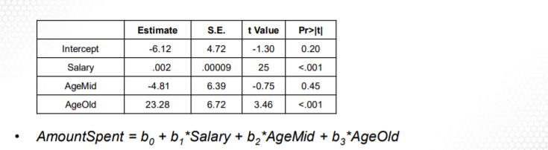Based on the following regression model summary (Note: the base case is Age = Young), what is the Amount Spent by a Middle-aged customer if his/her salary is 10000?
4. 20 – 6.12
5. 20 – 6.12 - 4.81
6. 20 – 6.12 +23.28
7. 20
8. An interaction term is used to model how the synergies between multiple variables impact the response variable.
9. True
10. False

Answers

Week1

Question 1: c The Sum of Squared Error (page 18 slide 1)

Question 2: c Sum of Squared Regression (page 18 slide 2)

Week2

Question 1: b. Dummy variable (page 9 slide 2)

Question 2: a. Height*Gender (page 18 slide 1)

Question 3: c (page 24 slide 2)

Question 4: c (Page 27 slide 2)

Question 5: d (Page 27 slide 2) $305*7

Question 6: b (page 20 slide 2)

Question 7: b (Lesson 2 / Video 4 / Slides 1 – 4)

Question 8: a (Lesson 2 / Video 4 / Slides 6 – 9)